

**SEMESTER TWO 2018**

**Classification Science Test:**

**ANSWER BOOKLET**

**NAME:**

**FORM:** **DATE:**

Multiple Choice Short Answer Total

**/26**

**/10**

**/36**

**SECTION ONE:** Multiple choice answers

Cross (X) through the correct answer.

|  |  |  |  |  |
| --- | --- | --- | --- | --- |
| **1** | a | b | c | d |
| **2** | a | b | c | d |
| **3** | a | b | c | d |
| **4** | a | b | c | d |
| **5** | a | b | c | d |
| **6** | a | b | c | d |
| **7** | a | b | c | d |
| **8** | a | b | c | d |
| **9** | a | b | c | d |
| **10** | a | b | c | d |

**Part B: Short Answer Questions (26 marks)**

1. Name: __________________________________________

Meaning: _____________________________________________________________________________________

_____________________________________________________________________________________

____________________________________________________________________________________

b. Name: _____________________________________________________________

Meaning: _____________________________________________________________________________________

_____________________________________________________________________________________

____________________________________________________________________________________

c. Name: _____________________________________________________________

Meaning: _____________________________________________________________________________________

_____________________________________________________________________________________

_____________________________________________________________________________________

If you decided it was living, what would you need to know to decide whether it was a plant or an animal?

_____________________________________________________________________________________

_____________________________________________________________________________________

_____________________________________________________________________________________

1. 1 feature the same:

_____________________________________________________________________________________

1 feature different:

____________________________________________________________________________________

|  |  |
| --- | --- |
| **ANIMAL** | **GROUP (A,B,C,D or E)** |
| **I** |  |
| **II** |  |
| **III** |  |
| **IV** |  |

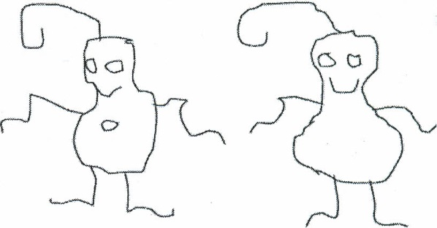4)

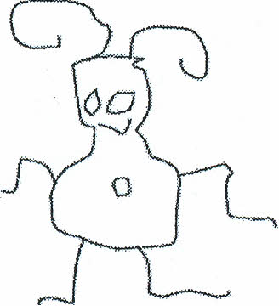

GLOP BIP GLIP

1. 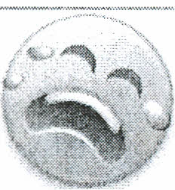

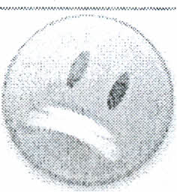





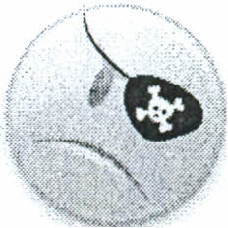

S.dramaticus

 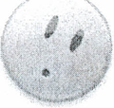   

*Smilus toothyus. Smilus upsettus Smilus valentinus*

*Smilus traditionalis Smilus saddus Smilus suprisus*

*Smilus piratus Smilus mutatus Smilus winkus*

*.*